ANARE Club – NSW Branch
Midwinter Lunch 2024
Saturday 29 June
Epping Tracks at the Epping Hotel
Opposite Epping Railway Station
58 Beecroft Rd Epping, Tel (02) 9876-1855
1115 hrs to 1600 hrs
(venue available until 1700hrs)

Your NSW Council cordially invites you, your partner and your guests, to attend the 2024 Sydney Midwinter Lunch.

If your Club membership is current we can admit you and your guests at members’ prices. As an incentive to join, the NSW Branch allows non-members (who otherwise qualify for membership) to attend on the understanding that they, plus any guests, pay a surcharge. Please return this response form with the details as set out below to lucinda.coates@riskfrontiers.com.

Member $85 per person, member & guests
Non-member $95 per person, non-members & guests
Commemorative mug - 70 Years at Mawson $5 per mug

ALL payments are to be received by Sunday 16th June.
This deadline will be enforced this year. No late registrations or payments will be accepted. If you have not paid for a ticket by this cutoff date, you will be unable to attend this year’s MWL.

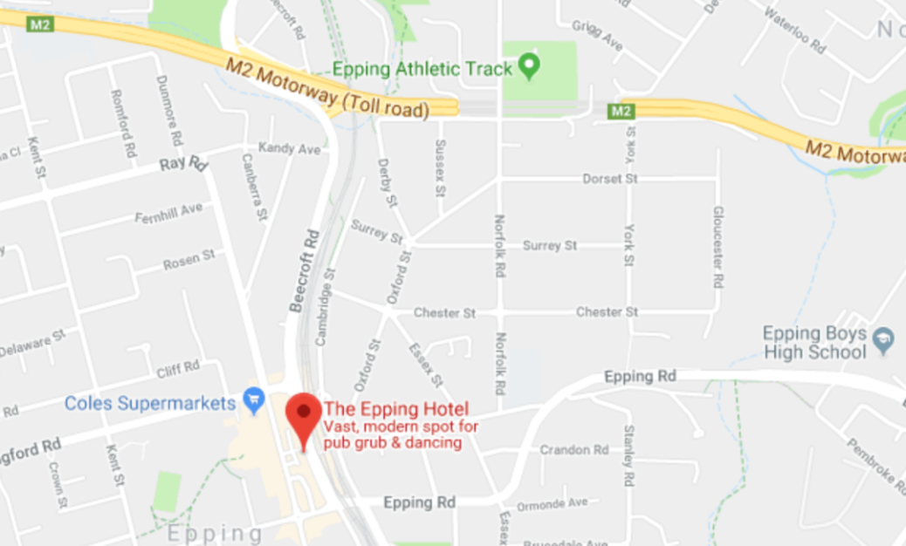 | Tracks at the Epping Hotel  Opposite Epping Railway Station  58 Beecroft Rd, Epping  http://www.eppinghotel.com.au  Tel: (02) 9876-1855

You can open and fill in this form in Microsoft Word. Choose one option to return.
1) Return via email to: lucinda.coates@riskfrontiers.com
2) Print it, fill it out and post to: Lucinda Coates, ANARE Club – NSW Branch, 8/ 6-8 Donald Ave, Epping NSW 2121

Attendance
Please place an X in the appropriate box:
□ I look forward to attending the MWL on Saturday 29 June 2024.
□ I regret I am unable to attend; please pass on my apologies and place my details, as shown below, in the programme.
□ I wish to notify that since last MW a close friend and expeditioner has passed away.
Details:

Details of those attending. You may bring partners, expeditioners, friends or send apologies.
Name you want on your nametag | Station & Year - Antarctic activity or interest
Your nametag and drink ticket will be available when you arrive at the door.

Cost
Members & guests | @ $85 per person | $
Non-members & guests | @ $95 per person | $
70 Years at Mawson commemorative mug | @ $5 per mug | $
 | TOTAL PAYMENT

Please indicate if any special meals are required:
□ Vegetarian □ Gluten Free □ Vegan □ Other (specify)
Guests with special dietary requirements to pick up their special place marker when they get their name tag at MWL.

Payment options
WE PREFER DIRECT DEPOSIT PAYMENTS

Option 1 - Direct deposit (“Pay Anyone” or “External Transfers”)
Important - please include your membership number or surname in the reference field. Then send this form via email to lucinda.coates@riskfrontiers.com
Payments can be made to:
BSB: 633000 | Account number: 122045578 | Account name: ANARE CLUB NSW

Option 2 - Cheque or Money Order
Enclose this form with your cheque or money order made payable to the ANARE Club-NSW Branch, and mail to:
Lucinda Coates, ANARE Club – NSW Branch, 8/ 6-8 Donald Ave, Epping, NSW 2121

NO tickets will be issued. However, you can confirm that your response has been received by viewing the NSW Branch pages on the club website; www.anareclub.org. Or you can contact Lucinda Coates (details as above).

If you have not provided your email address, or to update your details, please do so here:

